EXPERIMENT 5
Aim
To analyze the Stroke Prediction dataset using Python by creating a calculated field and basic visualizations such as bar charts, line charts, and pie charts.
Procedure
- Import Pandas, Matplotlib, and Seaborn libraries.
- Load the Stroke Prediction CSV dataset.
- Inspect the dataset.
- Create a calculated column named Patient Status.
- Create a bar chart for stroke cases by gender.
- Create a line chart for average glucose level by age.
- Create a pie chart for stroke and non-stroke patients.
- Display the visualizations.
Python Code
import pandas as pd
import matplotlib.pyplot as plt
import seaborn as sns

# Load dataset
df = pd.read_csv("healthcare-dataset-stroke-data.csv")

# 1. Create calculated field
df["Patient Status"] = df["stroke"].apply(
lambda x: "Stroke" if x == 1 else "No Stroke"
)

print(df[["stroke", "Patient Status"]].head())

# 2. Bar Chart - Stroke by Gender
sns.countplot(
x="gender",
hue="Patient Status",
data=df
)

plt.title("Stroke Cases by Gender")
plt.xlabel("Gender")
plt.ylabel("Number of Patients")
plt.show()

# 3. Line Chart - Average Glucose Level by Age
glucose = df.groupby("age")["avg_glucose_level"].mean()

plt.plot(glucose.index, glucose.values, marker="o")

plt.title("Average Glucose Level by Age")
plt.xlabel("Age")
plt.ylabel("Average Glucose Level")
plt.grid()
plt.show()

# 4. Pie Chart - Patient Status
status = df["Patient Status"].value_counts()

plt.pie(
status,
labels=status.index,
autopct="%1.1f%%"
)

plt.title("Stroke Distribution")
plt.show()
CODE OUTPUT
stroke Patient Status
0 1 Stroke
1 1 Stroke
2 1 Stroke
3 1 Stroke
4 1 Stroke
Output
stroke Patient Status
0 1 Stroke
1 1 Stroke
2 1 Stroke
3 1 Stroke
4 1 Stroke
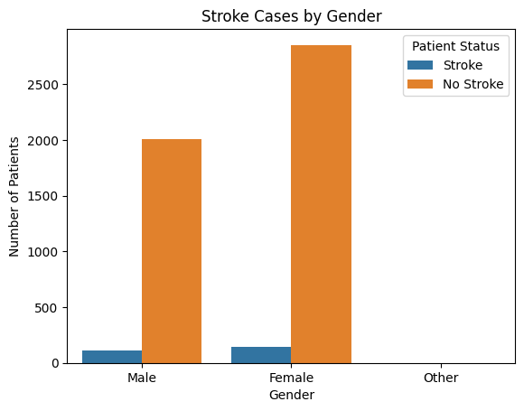
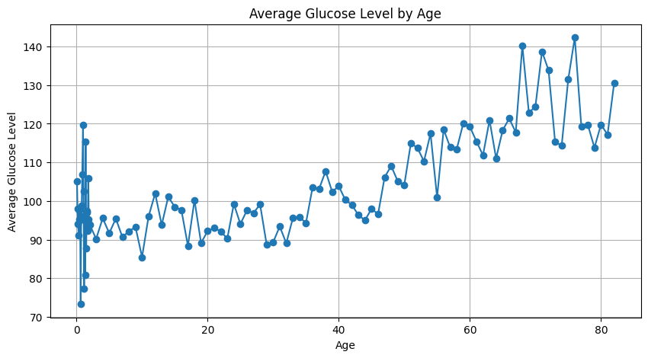
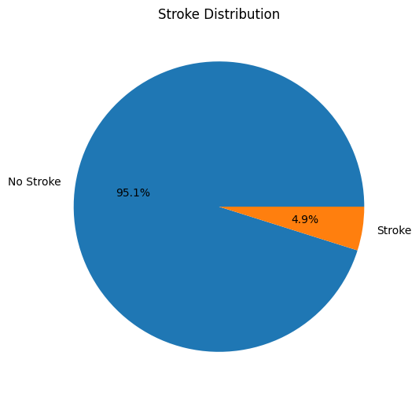
Stroke : 249 patients (4.9%)
No Stroke : 4861 patients (95.1%)
Result
The Stroke Prediction dataset was successfully analyzed using Python. A calculated field named Patient Status was created, and the data was visualized using bar, line, and pie charts. The visualizations provide a clear understanding of stroke patterns based on gender, age, glucose level, and patient status.

